
Name: _____________________

Pythagoras Theorem Investigation
Year 9

Time: 50 minutes Marks: / 42
Marks: / 5

Allowed: Take home section of notes and a calculator

Question 1 10 marks (1/2 mark each)

- Square the following numbers:  1  21  3  4  12  29  15  11  20  10 | - Square root the following numbers:  1  2  64  36  169  25  16  9  144  225

Question 2 3 marks

Circle the hypotenuse on the following diagrams.

C  A  B | A  B  C | C  B  A

Question 3 12 marks

Use the converse of Pythagoras Theorem to determine whether each of the following triangles is a right-angled triangle. Show all working out.

5 cm  4 cm  3 cm | 2 cm  4 cm  3 cm  6 m
6 mm  5 mm  3 mm | 10 m  8 m

Question 4 5 marks

Sometimes we can proof Pythagoras Theorem using different shapes. Using the area of a semi - circle ($A=\frac{1}{2}πr^{2}$) prove that the following triangle is a right-angled triangle. Show all working out.

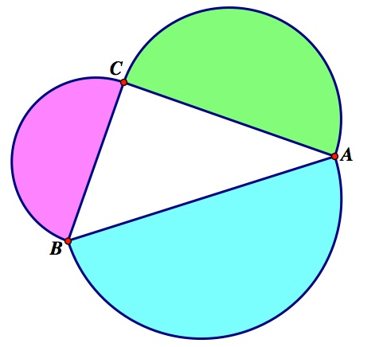

16 m

12 m

20 m

Question 5 12 marks (2,2,4,4)

Calculate the unknown sides of the right angle-triangles. Show all working out.

20.4 cm  11.2 cm  x | x  8 m  15 m

- A kite is on a 35m string and is a horizontal distance of 22m from the person flying the kite. How high is the kite above the ground? Construct a diagram showing all the relevant details.

- Larry always takes a shortcut through Farmer Fred’s paddock. Bezerko the bull chases Larry because Larry wears red socks. If Larry is at point L and Bezerko is at B, how far does each have to run to get to the gate?
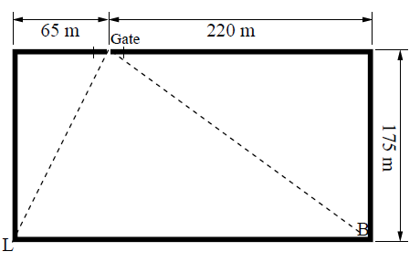

End of Test

